Analytics & Information Management Systems Employee Onboarding Plan
Jill Thonssen
ENG 315 Business & Professional Writing
Sara Keller
May 19, 2019

Analytics & Information Management Systems Employee Onboarding Plan

My Final Project is creating an onboarding plan for my organization, Analytics & Information Management Systems (AIMS). Onboarding is defined as ‘formal and informal practices, programs, and policies enacted or engaged in by an organization or its agents to facilitate newcomer adjustment’. (Klein. 2015. p263) The company provides a well-established and thorough enterprise-level orientation program owned and executed by the Human Resources organization. Each business unit or organization is then responsible for their own onboarding plan and package, taking up where the enterprise-level orientation left off. However, AIMS does not have a documented organizational onboarding plan. Currently the depth and execution of onboarding is dependent on each manager, creating an onboarding experience that is complex, inefficient, inconsistent, and overly taxing for new hires which, in turn, delays the integration of employees into AIMS. The purpose of creating an AIMS Onboarding Plan is to ensure comprehensive and consistent onboarding to every new employee in AIMS which will improve employee satisfaction and retention. (Heddleston, 2018) From a human capital perspective, the sooner and the extent to which newcomers can learn firm specific knowledge, understand the culture, and recognize other unique aspects of the organization, the sooner and the extent to which they can contribute to the success and competitive advantage of the organization. (Klein. Sept 2015. p263) The goal is to create a world class onboarding experience for all new and transferred employees. The need for an organizational onboarding plan, including content and delivery, is supported by research and data; it is clear that those organizations without an onboarding plan risk higher turnover, higher costs, and lower employee job satisfaction.
Onboarding is the organization’s chance the make their first impression. Yet, most companies do not do onboarding well despite the all the research and data showing the importance of onboarding. As explained by Workforce –
Did you know that within six months of being hired nearly one-third of employees are already looking for a new job? When you consider the cost and time associated with bringing on each new employee, this statistic should be alarming. A new employee's decision to stay or go depends largely on first impressions, yet many organizations put little thought or planning into that critical first-touch experience -- the onboarding process. (Workforce, 2013. p#1)
This information should be alarming as the purpose and need for onboarding is clear. The reasons for good onboarding practices are also clear. Organizations use onboarding practices to (a) reduce the inevitable uncertainty and anxiety newcomers experience, (b) help them make sense of their new environment, and (c) provide them with the necessary tangible (e.g., explicit knowledge) and intangible (e.g., relationships) resources to become fully functioning organizational members effective in their new role. (Klein. Sept 2015. p264)
The data shows just how vital it is for AIMS to have an effective onboarding plan. In the last 12 months, AIMS has increased their employment numbers by nearly 80 employees. And that is strictly total headcount (308 to 382); it does not include a total count of new employees. This means AIMS had the opportunity to onboard a MINIMUM of 80 employees in the last year, yet only a fraction of those employees received any formal onboarding once part of the AIMS organization. The results of a survey of the 21 employees who joined AIMS between January and April 2019 indicated the following:
- Several of the respondees did not meet with their immediate manager on the first day and 76% met with their manager for less than an hour on that first day (Refer to Figure 1)
- Over half (57%) of the new employees were not provided information on the Vision/Misson/Goals of the AIMS organization (including location of the AIMS website and AIMS Employee portal web page) (Refer to Figure 2)
- 85% were assigned a buddy or mentor on that first day (Refer to Figure 2)
- Nearly 40% of the new employees took more than a week to start on a project (Refer to Figure 3)

Figure 1 – Onboarding Survey Question 1

Figure 2 – Onboarding Survey Questions 2 and 3

Figure 3 – Onboarding Survey Question 4

These results are not acceptable. It is a waste of talent and productivity. If AIMS strives to be THE organization that everyone in IT wants to work for, we need to do a much better job of onboarding our employees. The expectations of the users of the AIMS Onboarding Plan (S. Stevens, personal communication, April 2019):
- They want to be informed, including knowing upfront what’s needed to successfully complete the process and expectation of how long the process will take.
- They want to access information that pertains specifically to them and not have to read through material that doesn’t apply to them.
- They want the process to be easy, but to have a way to contact a person or group if they run into trouble.
The AIMS Onboarding Plan would consist of two main parts; Content and Delivery. The main content for the onboarding plan is outlined in the “Employee Onboarding Framework” figure in the Appendix. The enterprise-level plan (by HR) is responsible for the Pre-boarding and Elements 1 and 2. Pre-boarding and Elements 1 and 2 reflect the more traditional orientation portions. But orientation is NOT onboarding. (Hirsch, 2017) Traditionally orientation is focused more on administrative items such as company procedures and policies, benefits, timekeeping, etc. Orientation is not usually focused on the more cultural or social aspects of the organization or the job. That is where onboarding comes in. Each business unit or organization is responsible for Elements 3 and 4. Content for onboarding is varied and not limited to just the items listed in the Employee Onboarding Framework. It needs to include high-level items such as AIMS Vision, Mission, and Goals, organizational charts, historical information, culture, and review of our major or critical projects. But the onboarding plan should also include detailed information such as links to SharePoints, documentation, access to tools and software, detailed organization charts, timekeeping instructions, etc.. The onboarding plan needs to provide the high-level information about the organization along with the specifics an employee requires to do their day-to-day work and their roles and responsibilities. The sooner you can make an new employee productive, the better. As Steer (2013) stated “What younger employees want is to actually start working. The thought of sitting around doing nothing or being talked at, is not what they had in mind.” (p. 27). Therefore, the onboarding plan should have a healthy balance of getting and absorbing information and actually delivering work. Too often organizations are heavy on one or the other. Some expect new employees to sit in their workspaces and read binders full of policies and procedures, or go through endless e-learning programs. Others have demand for work and expect new employees to contribute immediately; this can result in low-quality, mistake-filled work, which results in frustration for new hires and the organization. (Answering 6 Most Critical Questions About Employee Onboarding, 2017. p#11) Understanding what new employees need to feel productive, supported, and part of the team is an essential part of the onboarding plan.
Content also includes responsibilities or actions from both the AIMS and new employee perspectives. The manager of the new hire has actions to complete before and during the onboarding process. There will be a timeline or schedule to follow to ensure the manager is doing the required actions at the right time, including checking in with the new employee at various intervals to ensure the new employee is getting the necessary information, support, and feeling like a productive member of the team. The new employee will also have actions to complete during the onboarding process and a timeline to follow.
The second part of the onboarding plan is Delivery. “The key to effective onboarding is doing the right activities at the right time.” (Steer, 2013, p. 27). But that differs depending on the employee (new to the company or just new to AIMS), the job role, and even the individual learning style. So it is imperative the onboarding plan is customizable. This allows employees to pick and choose the elements of the onboarding that seem most relevant to them. (Steer, 2013, p. 28). This also avoids the issue of ‘forcing’ employees to work through elements or modules which do not apply to them or their job, which can be discouraging and result in an employee not completing their onboarding plan. Another facet to delivery is technology. Automating the content and delivery is essential, especially when onboarding an employee into an IT organization. Finally, the onboarding plan should also be accessible or retrievable, as needed. For the first few days or weeks most new employees will feel overwhelmed by information. By ensuring they can retrieve the onboarding information at any time, it allows them to review any information or data as needed when they need it.
The necessity for effective onboarding and the cost of NOT having an effective onboarding plan is explained by Workforce –
A good onboarding program can have a dramatic effect on retention, productivity and job satisfaction. A 2013 Aberdeen report shows that companies with best-in-class onboarding programs report a 91 percent retention rate compared with 30 percent at the lowest-performing companies. (Workforce, 2013. p#4)

A successful onboarding plan will include these recommendations from Stacey Stevens (personal communication, April 2019):
- Timeline for onboarding plan, including expected time allotment for each step. This will help management and employees not only plan but also track progress.
- Automate the plan as much as possible, including checklists, forms, and access to help
- Enable customization of the onboarding plan/package so employees can skip the parts that do not apply to them.

With approval from senior leadership, I will form a team to create and design an effective and comprehensive onboarding plan for the AIMS organization. The team will include at least one manager and one staff analyst. Deadline for the initial onboarding plan is end of 2nd quarter 2019. Included in this project is the onboarding plan, checklists, content, timeline, and metrics. The goal is to create a world class onboarding experience for all new and transferred employees that reduces employee turnover, reduces costs for the organization related to new employees, and increases employee job satisfaction.
References
Answering 6 Most Critical Questions About Employee Onboarding. Connect the Dots Consulting. March 28, 2017. Retrieved from: http://www.connectthedotsconsulting.com/blog/2017-03-28-1742/answering-6-most-critical-questions-about-employee-onboarding
Get Onboard With Onboarding. Workforce, 23312793, Nov2013, Vol. 92, Issue 11. Retrieved from: http://eds.a.ebscohost.com.proxy-library.ashford.edu/eds/detail/detail?vid=6&sid=794d6686-d21c-4c27-8601-b3555a208848%40sessionmgr4009&bdata=JnNpdGU9ZWRzLWxpdmUmc2NvcGU9c2l0ZQ%3d%3d#AN=96996941&db=f5h
Heddleston, K The Importance of Technical Onboarding, Training, and Mentoring. (2018) Retrieved from https://learning.oreilly.com/videos/the-importance-of/9781492038894
Hirsch, A. Don't Underestimate the Importance of Good Onboarding. (August 10, 2017). Retrieved from https://www.shrm.org/ResourcesAndTools/hr-topics/talent-acquisition/Pages/Dont-Underestimate-the-Importance-of-Effective-Onboarding.aspx
Klein, Howard J.; Polin, Beth; Leigh Sutton, Kyra. Specific Onboarding Practices for the Socialization of New Employees. International Journal of Selection & Assessment (September 2015) Vol. 23 Issue 3, p263-283. 21p. Retrieved from: Specific Onboarding Practices for the Socialization of New Employees.
Steer, Dan. Onboard With It All. T+D. (November 2013), Vol. 67 Issue 11, p26-29. Retrieved from: http://eds.a.ebscohost.com.proxy-library.ashford.edu/eds/pdfviewer/pdfviewer?vid=4&sid=794d6686-d21c-4c27-8601-b3555a208848%40sessionmgr4009
Stacey Stevens, personal communication via e-mail, April 2019

Appendix
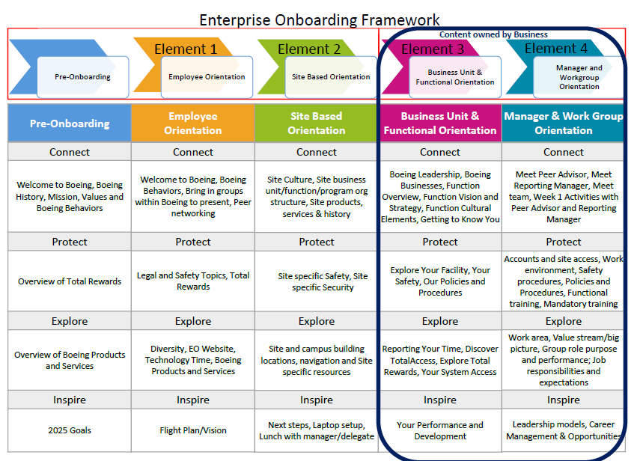
Figure 1 – Enterprise Onboarding Framework (The Boeing Company, March 2019)

